# Algorithm for file updates in Python

## Project description

An algorithm that parses a text file of IP addresses and updates the file by removing addresses that no longer have access to the restricted content.

## Open the file that contains the allow list

First, we create a variable named “import_file” that contains the name of the file we want to inspect. Next we create a list of restricted IP addresses. Then, we open the file using “with open()”. To read the content of the file we specify the name and mode as “r”. We name the opened file as “file”.

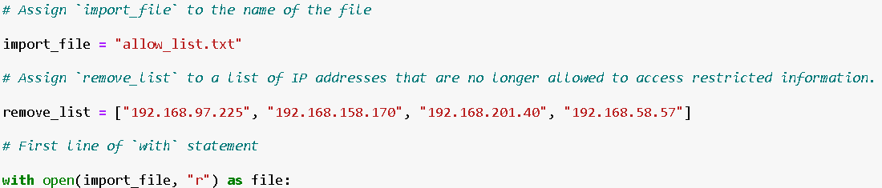

## Read the file contents

In the “with” statement we create a new variable “ip_addressess” which will store the IP addresses from the specified file. We can read the contents of that file using the .read() function.

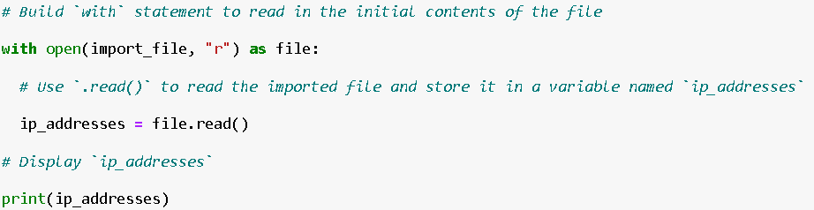

## Convert the string into a list

Next, we need to convert the string of IP addresses into a list. We can do this using the .split() function. As the argument of this function, we can specify the delimiter. In this case the delimiter is not necessary, because we want to split the string by space.

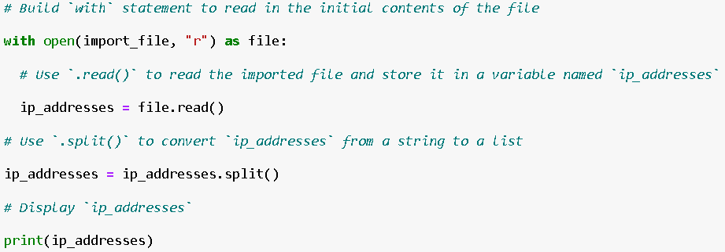

## Iterate through the remove list

To iterate through the remove list, we create a simple for loop. We name the loop variable as “element” and iterate through a variable called “remove_list”, which contains elements to remove.

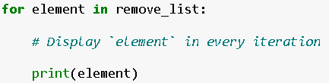

## Remove IP addresses that are on the remove list

To remove IP addresses that are on the remove list, we create an if statement. This statement checks if the current loop element is present in the ip_addresses list. If this is evaluated to be true, we simply remove this element from the list of IP addresses using the .remove() function. We pass the current element as an argument to the .remove(element) function.

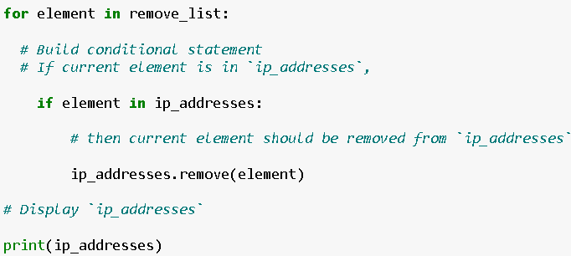

## Update the file with the revised list of IP addresses

To update the file of IP addresses we need to convert the list to string variable. We can do this using the .join() function, which joins all the list elements into one string and separates it with a space. Then we open the import_file again, but this time using the “w” mode to re-write the contents of it. Inside the with statement we use the .write() method with ip_addresses as an argument. This allows us to write the newly created string of IPs inside the file.

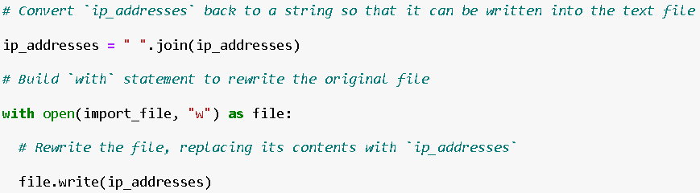

## Summary

The project aims to create an algorithm in Python for managing IP addresses within a text file that contains a list of permitted addresses. Initially, the algorithm opens the file, reads its contents, and converts the string of IP addresses into a list. It then iterates through a provided removal list, removing any matching IP addresses from the main list. After updating the list of IP addresses, the algorithm converts it back into a string and rewrites the file with the revised content. This process ensures the file contains an updated list of IP addresses permitted to access restricted content, facilitating effective management of access permissions.